Part 1 - Overview of Fabric CI/CD
Microsoft Fabric is a unified analytics platform designed to bring together different data and analytics tools into a single, integrated software-as-a-service (SaaS) solution. Microsoft Fabric caters to data engineers, data scientists, and analysts who need to collaborate on analytics and AI projects. The Fabric platform adds value by reducing complexity while still making it possible to build, deploy and manage enterprise-scale projects focused on analytics and AI.
The Microsoft Fabric platform attracts people with different technical backgrounds. For example, there are data engineers tasked with creating notebooks to ingest and transform data to populate lakehouse tables. There are data modelers tasked with building and refining semantic models on top of lakehouse tables. There are report designers tasked with authoring and updating Power BI reports that are built on top of those semantic models. Once you understand how CI/CD works in Fabric, you will be able enable collaboration which allows all these people to continually update their part of a Fabric project without stepping on anyone else’s work.
This article is written to provide guidance to data engineers, release managers , Fabric administrators and professional developers building end-to-end solutions on the Fabric platform. This article explains how to setup the CI/CD infrastructure for analytics and AI projects in Fabric as well as how to deploy and manage the CI/CD lifecycle of workspace items such as lakehouses, notebooks, pipelines, semantic models and reports. This article starts with an overview of the Fabric CI/CD landscape covering essentials concepts and features. After this overview, the article will move through the steps of setting up a real-world Fabric CI/CD project which enables collaboration and provides a structured release process.

Quick Review of Traditional CI/CD Fundamentals
CI/CD represents a set of core principles and best practices that have been widely adopted across the software industry. The goal of CI/CD is to streamline and accelerate the lifecycle of software development. CI/CD focuses on two different aspects of managing the application lifecycle which are continuous integration (CI) and continuous deployment (CD).
Continuous integration (CI) is the practice of frequently merging code changes into a shared repository. Each time developers merge their changes, it can trigger automated workflow processes that ensure the application code as a whole still works together by running validation tests. CI makes it possible to detect bugs and other problems early on. This, in turn, makes it possible to maintain a codebase that's always in a working state and ready to deploy to a production environment.
Continuous integration is popular because it allows a team of developers to work on the same application at the same time. CI/CD solves the challenging problem of integrating the work of multiple developers into a shared codebase in an ongoing basis. Once you have designed and implemented a GIT branching strategy, you’ll be able to merge everybody’s changes together in a structured process that maintains code quality while also getting updates and new features into production as quickly as possible.
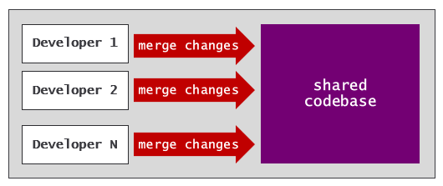
Continuous deployment (CD) is the practice of automating the deployment of code. Deployment is often preceded by some type of interactive human approval process. Once a set if proposed changes has been approved, a CD process is automatically triggered to deploy these changes to a target environment.
With continuous deployment, you can build automated processes to route the lifecycle of application code through a set of stages. Promoting code changes through a set of stages provides opportunities for enhanced testing and for interactive approval processes that ensure only high quality code reaches the production environment. The release process in a CI/CD workflow is often built using stages to simulate different environments such as dev, test and prod.
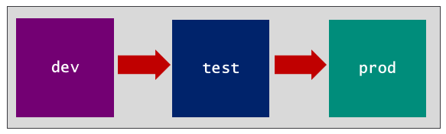

Fabric CI/CD Capabilities
Support for CI/CD in the Fabric platform is built on a few essential capabilities. Fabric provides GIT integration as the foundation used to implement continuous integration. Fabric provides deployment pipelines as a mechanism for implementing continuous deployment. Fabric provides variable libraries to assist with the parameterization of environment settings across workspaces and workflow stages. This section will drill into these Fabric CI/CD features to build your understanding of how they fit into the big picture.

Fabric GIT Integration
The Fabric platform's CI/CD infrastructure starts with its support for GIT integration. Imagine you’re on a team building a data analytics solution based on a Fabric workspace that includes a lakehouse, notebook, semantic model and report. Fabric makes it possible to maintain the source code for all four workspace items as a single source of truth in a GIT repository. Any updates made to workspace items can be versioned, tracked and compared to other versions.
Fabric's list of supported GIT providers includes Azure DevOps, GitHub and GitHub Enterprise. Microsoft is currently planning to add other popular GIT providers in the future. You can find the most up-to-date information about Fabric's support for GIT providers and their limitations by reading Supported Git providers.
Fabric’s support for GIT integration is enabled at workspace scope. More specifically, you enable GIT integration by connecting a workspace to a branch in a GIT repository. If you navigate to the Git integration tab of the Workspace settings dialog, you can work through the steps to connect a workspace and a branch in a GIT repository using a GIT provider such as Azure DevOps or GitHub.
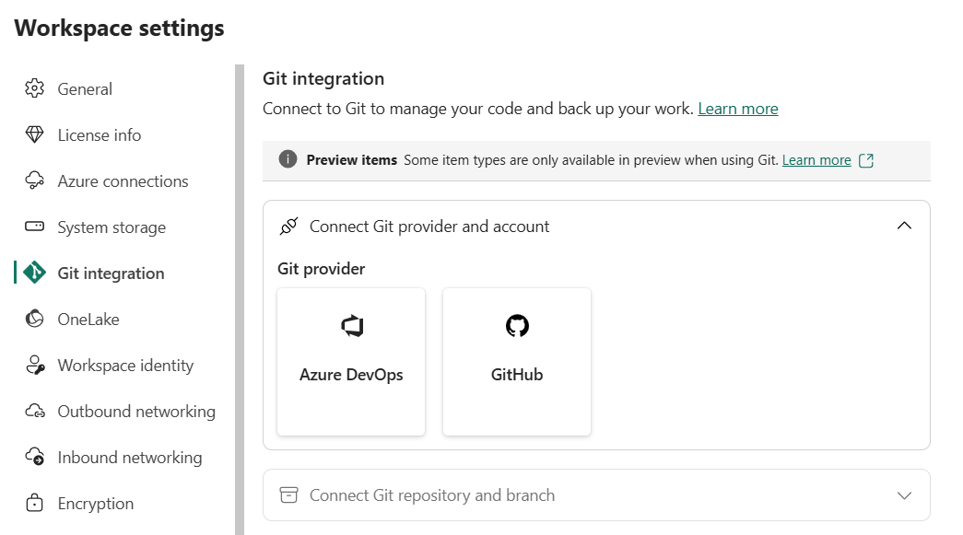
Before connecting a workspace to a branch, you need to create a Fabric connection to the target GIT repository. Fabric provides one connector for creating Azure Dev Ops source control connections and another connector for creating GitHub source control connections. When creating a connection to an Azure DevOps repository, you can configure connection credentials using a service principal. When creating a connection to GitHub, you must configure the connection credentials using a personal access token (PAT).
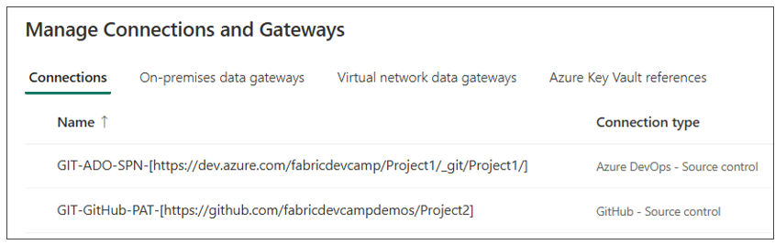
It is a best practice to create these types of GIT source control connections using an API or a tool such as Terraform. This article will examine these details later in the walkthrough of setting up a Fabric CI/CD project.
More information
- Managing your personal access tokens I GitHub
If you select Azure DevOps as the GIT provider and create a source control connection to the target Azure DevOps repository, you must then select an Organization, Project, Git repository and Branch. Optionally, you can include a Git folder setting.
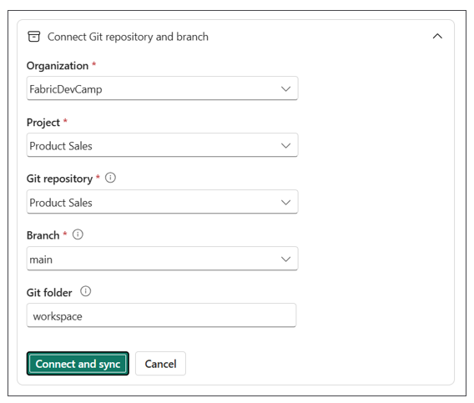
This examples shown in this article will use Git folder setting of workspace. However, you can use any name you’d like.
Specifying a Git folder setting allows you to avoid storing the folders containing workspace item definitions in the root folder of the target repository. Using a Git folder setting is recommended in scenarios where you need to add other project files to the same GIT repository. In a Fabric CI/CD project, it's common to add YAML files for defining workflows as well as other types of files used to implement workflow logic such as shell files, PowerShell files and/or Python files. By configuring a GIT folder setting, you avoid the confusion mixing the workspace item definition files together with other types of project files.
The GIT folder setting also makes it possible to connect multiple workspaces to a single branch. Consider a use case where a Fabric solution is spread out across two workspaces with a staging workspace and a presentation workspace. The staging workspace can be connected to a branch with the Git folder setting of workspace/staging while the presentation workspace can be connected to the same branch with a Git folder setting of workspace/presentation. Event though this type of solution is spread out across multiple workspaces, the source code for the entire project is tracked in the same branch.
Now imagine you have deployed a data analytics project to a workspace which includes a lakehouse, a notebook, a semantic model and a report. When you first connect the workspace to a GIT repository, Fabric will generate a serialized definition for each workspace item which it commits to the target GIT branch as a named folder containing a set of item definition files. If you used a GIT folder setting of workspace, you should see a top-level folder named workspace with a child folder for each workspace item. The Fabric workspace UI provides a GIT status column that displays Synced indicating all workspace items are in sync with the item definitions stored in the GIT repository.
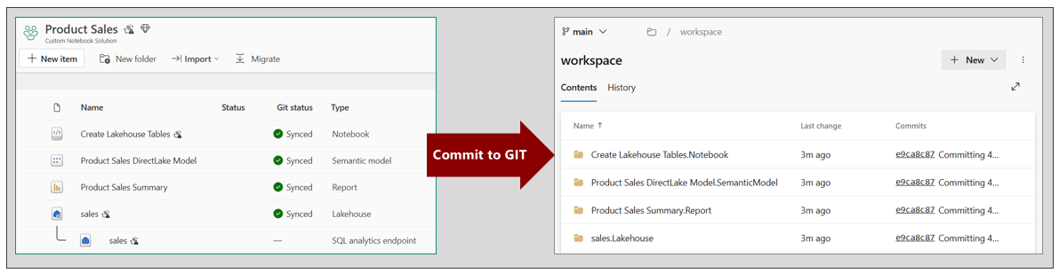
Fabric uses a naming convention for workspace items which includes item display name, a period and the item type in the format of [Item Display Name].[Item Type]. You can see from the previous screenshot that GIT synchronization creates folders using this naming convention for folder names such as sales.Lakehouse and Product Sales Summary.Report.
In the simplest use case, you can connect a workspace to a GIT repository with a single branch. This simple setup allows you to begin taking advantage of Fabric GIT integration. For example, you have the ability to version workspace items. You also have a backup mechanism giving you the ability to revert to previous versions of a workspace item if something goes wrong with an update.
Let's say you have a workspace and you have connected it to a GIT repository with a single branch named main. At first, the workspace items are in sync with the item definitions in GIT. Next, you open a report in the browser, navigate to edit mode and make a few changes. Once you save your changes, the updated report is no longer in sync with the item definition in GIT. The Fabric workspace UI displays a Source control button in the upper right shows that indicates there is a workspace item with uncommitted changes. You can also see the Git status column for the report displays Uncommitted.
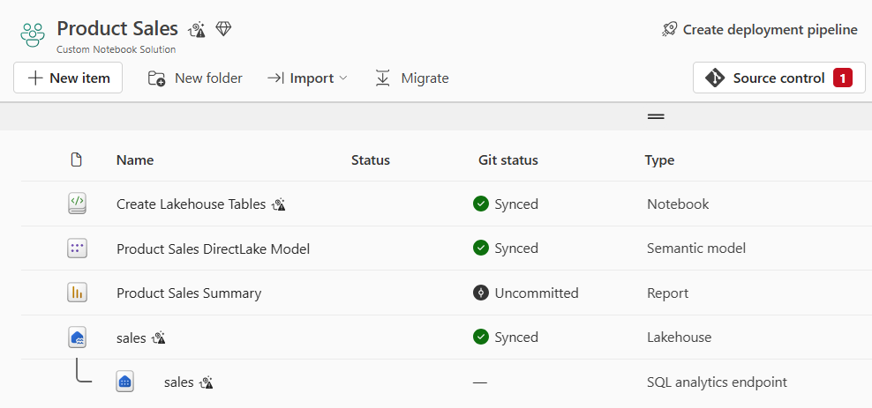
If you click the Source control button, that will open the Source control pane on the right side of the page. The Source control pane has two tabs named Changes and Updates. The Changes tab shows the workspace items which have changes that have not yet been committed to GIT.
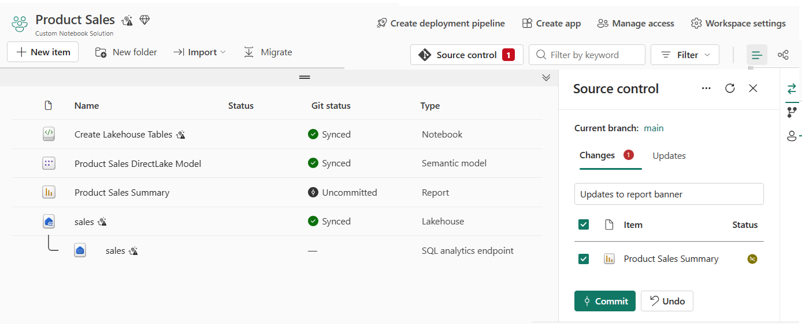
What happens if you made a mistake while editing the report and accidently saved your changes? You can click the Undo button to return the report to its previous state before you started editing. Clicking the Undo button will discard any changes made to the workspace item and return it to its previous state by synching state from the underlying GIT branch.
Once you have made updates to the report and saved the changes, you can click the Commit button to push the changes to GIT. You should take note that there is a small textbox at the top of the Changes tab. This textbox allows you to enter a commit message which gets recorded in GIT. While the Fabric UI does not enforce adding a commit message, you should build the discipline to always enter a useful and descriptive message about what is being committed. If you leave the textbox empty, Fabric generates a generic commit message which doesn’t really indicate what was updated or why.
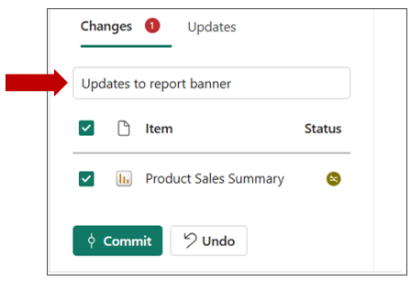
You haven seen that you can use the Commit button to push changes to workspace item to a GIT branch. However, you can also synchronize changes in the other direction. Think about a scenario in which a workspace is synchronized with a GIT branch. After that, new changes are merged into the branch from a source other than the workspace item. Those changes in the GIT branch can be pulled into the workspace and used to synchronize workspace items.
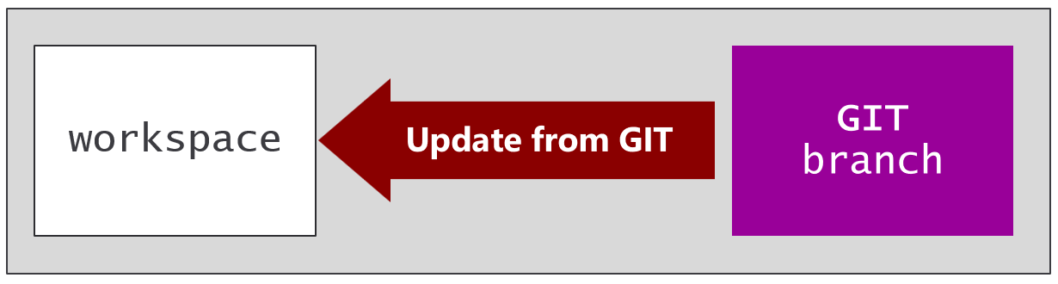
Consider a scenario in which you have updated a report and committed your changes to GIT. After that, you realize that there is a problem with the update and you'd like to roll it back. You can go to the GIT repository and revert the commit that contains the undesirable changes. Reverting a commit is often accomplished using a pull request which makes the reverted commit appear as new changes within the branch. When Fabric detects new changes in the underlying GIT branch, it determines that the report is no longer in sync and the Git status column displays Update Required.
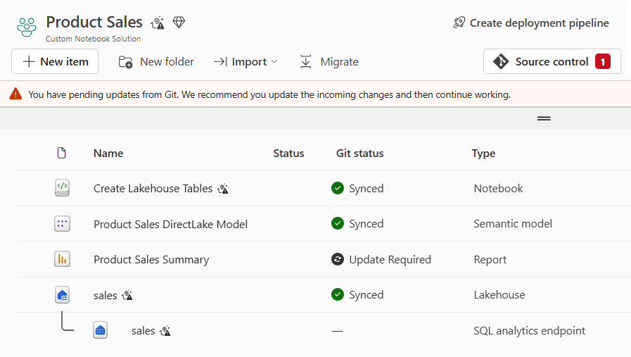
You can update the report by navigating to the Updates tab of the Source control pane and clicking the Update all button. Clicking Update all will synchronize the report by applying the changes merged into the branch. This will effectively roll back the changes to the report that were previously commit to GIT.
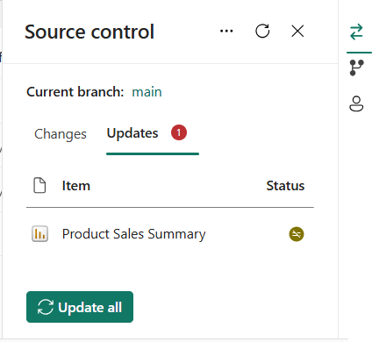
If you update a report in the browser, the Git status for that item will continue to display Synced until you first save your changes by invoking the Save command. Other types of workspace items exhibit auto-save behavior and don't require an explicit save operation before they begin to show a Git status of Uncommitted.
You have now seen that GIT integration allows you to synchronize updates in two different directions. After you've updated a workspace item, you can commit those changes to GIT. You can also update from GIT to keep workspace items in sync with changed merged into the underlying GIT branch. However, GIT integration in Fabric allows you to go on step further. You can create an empty workspace and initialize it using a Deploy from GIT operation which uses the items definitions in a GIT branch to create a matching set of workspace items.
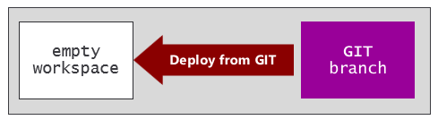
Consider a scenario in which you have a prod workspace which has been connected to a GIT repository with a single branch named main. You can create one or more other workspaces for development purposes. For examples, you can create a named workspace named dev1 as an empty workspace and then connect it to the same GIT branch main.
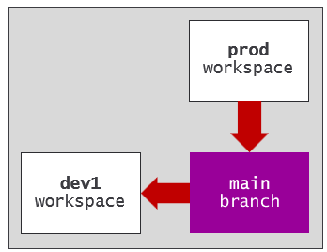
When you connect the dev1 workspace to the same branch with the same Git folder setting as the prod workspace, Fabric will react by automatically creating a set of workspace items in the dev1 workspace to match the set of workspace items in the prod workspace. The dev1 workspace is isolated from the prod workspace so that it can be safely used for development.
When you initialize a workspace using a Deploy from GIT operation, the workspace usually requires additional configuration before it's ready for development purposes. This is an important topic that will be revisited shortly.
You can now update a report in the dev1 workspace without affecting anything in the prod workspace. After updating the report in the dev1 workspace, you can save your work and commit the changes to the main branch. Once the changes have been committed to the main branch, you can click the Update all button to apply the changes to the report in the prod workspace. Alternatively, you can develop a workflow that runs automatically when changes are merged to main which automates the process of synchronizing changes to the prod workspace.
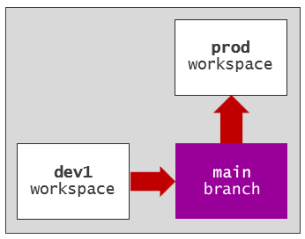
For those who are new to working with GIT, you must be mindful of avoiding merge conflicts. A merge conflict occurs in Fabric when changes are made independently to both a workspace item and its corresponding item definition in GIT. You can update one or the other, but you can't update both. When Fabric detects a workspace item has a merge conflict, the Git status column displays Conflict and the Commit button is disabled for that workspace item. When you experience merge conflicts, you must take some type of corrective action to resolve them before you can commit your changes.
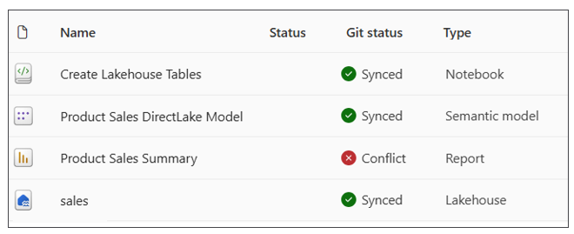
More info
- Resolve conflict in a Fabric workspace
A development model which involves merging all changes into a single GIT branch is known as trunk-based development. When you have multiple workspaces connected to a single GIT branch, there is an increased risk of merge conflicts. You must have the discipline to ensure changes flow in only one direction. As an example, let's say you've updated the report in the dev1 workspace but haven't yet committed your changes to GIT. What happens if someone else updates the same report in the prod workspace and commits those changes to the main branch? This will create a merge conflict which restricts you from being able to commit the changes you've made in the dev1 workspace.
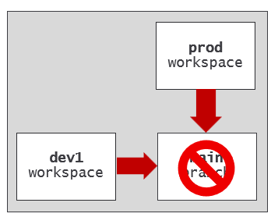
You have just seen a simple example of using a trunk-based development model with a single GIT branch. This approach makes it possible to conduct development work in isolated workspaces while avoiding the complexity and overhead of a branching strategy and pull requests. Since there is only one branch, it eliminates the risk of merge conflicts between branches. For this reason, trunk-based development provides the quickest and most direct way to get changes into production.
Trunk-based development also has its drawbacks. It requires a team of disciplined and experienced people that know what they are doing. Anyone can merge whatever they want directly into main branch at any time. With trunk-based development, there isn't much control over what changes get merged into the production codebase. The alternative to trunk-based development is to adopt a branching strategy based on feature branches and pull requests.

Contiguous Integration using Feature Workspaces
The use of features branches has become widely adopted due to popular branching strategies such as Gitflow or GitHub Flow. A branching strategy which includes feature branches allows developers to work and commit changes in isolation. You can also configure a feature branch with workflows that run automatically whenever changes are committed. These workflows can automate running tests with linters, validation checks and security scans into the continuous integration process to improve the quality of code that reaches production.
After committing changes to a feature branch, the next step is to create a pull request to merge those changes to the release branch. You can think of a pull request as a proposal that allow collaborators and release managers to review and discuss a proposed set of changes. GIT providers such as Azure DevOps and GitHub make it possible to configure a pull request with an interactive approval process that is as simple or as complicated as required for a given scenario. When the approval process completes successfully, the changes are automatically merged to the shared codebase known as the release branch.
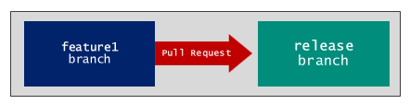
More info on ceating and managing pull requests
- Create pull requests in Azure Dev Ops
- Creating a pull request in GitHub
Many developers moving to Fabric with prior CI/CD experience are already familiar with feature branches and pull requests. From the perspective of traditional CI/CD, creating a feature branch is a quick, inexpensive operation that allows you to get up and running right away. Things are quite different in a Fabric CI/CD project because each feature branch must be paired up with a feature workspace.
While creating a feature branch is always quick and easy, the same is not always true for creating a new feature workspace. To create a feature workspace, a developer requires permissions in Fabric in addition to permissions in the GIT repository. For example, a developer needs Fabric permissions to create new workspaces and permission to assign workspaces to a Fabric capacity. There's also a requirement to create or find a GIT source control connection which is used to connect the feature workspace to the target feature branch.
Keep in mind that a Fabric connection to GIT source control has a path relative to the repository. The path does not include the branch. That means you can create a single GIT source code connection to Azure DevOps or GitHub and reuse this connection to connect multiple workspaces to any number of branches in a target GIT repository.
Consider a scenario in which you have connected the prod workspace to the main branch. The main branch acts as the release branch because it contains the workspace item definitions that represent the single source of truth. If you create a new branch from main named feature1, this new branch will initially contain an identical copy of each workspace item definition in main. Next, you can create an empty workspace named featue1 and connect it to the feature1 branch. This triggers Fabric to automatically run a Deploy from GIT operation to populate the feature workspace with a matching set of workspace items.
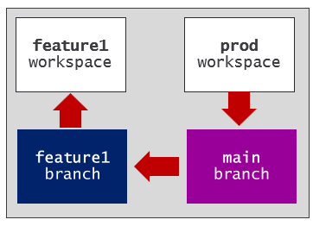
The release branch is an essential concept in continuous integration. The release branch is the shared branch where everyone's changes are merged together. It's called the 'release branch' because its contents represent the single source of truth that is always ready for deployment to test and production environments.
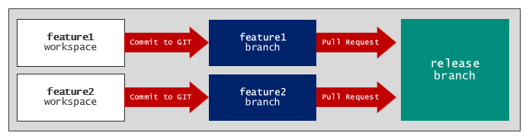
After a feature workspace has been initialized with a deploy from GIT operation, there is often additional configuration work required to prepare the workspace for development. For example, the deploy from GIT operation will create a lakehouse, but it will not automatically populate the lakehouse with data. Semantic models lack connections and might be pointing to the wrong datasource.
You can address these types of issues by writing scripting logic which runs after GIT synchronization occurs. As you begin to script out workflow logic, you need to differentiate between post-deploy jobs and post-sync jobs.
A post-deploy job is a process that must be run only once after an empty workspace has been initialized with a deploy from GIT operation. Examples of what to do in post-deploy jobs are running ETL logic to populate lakehouse tables with data as well as creating and binding connections to semantic models. You can think of a post-deploy job as a set of one-time tasks that are part of the workspace initialization process.
A post-sync job is a process that must be run each time after Fabric GIT integration pushes changes from a GIT branch to a target workspace. Examples of post-sync tasks include updating the definition of a semantic model so that it continues to point to a lakehouse in the same workspace.
Keep in mind that Feature branches are typically short-lived. You don't want them hanging around too long because that increases the risk of merge conflicts. It's a common practice to delete feature branches as soon as a pull request completes and merges its changes to a release branch. There are a few options for managing the lifecycle of feature workspaces. One option is to manage feature workspace lifecycle to coincide with feature branches. When a pull request completes, you delete both the feature branch and the feature workspace. A second option is to delete just the feature branch and to keep the feature workspace around for use with a different feature branch.
The Fabric UI provides built-in commands for creating and managing feature workspaces. The Source control pane provides a small navigation menu in the upper right-hand corner. If you click the branching button in this navigation menu, the Source control pane displays new branching options.
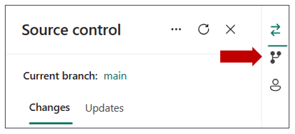
After clicking the branching button, the Source control pane displays a dropdown menu with branching commands.
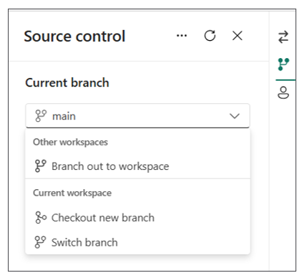
When you run the Branch out to workspace command. Fabric prompts you with a dialog with options for creating a new feature branch and associating it with a feature workspace. There is an option to create a new feature workspace or to use an existing feature workspace. Remember that creating a new feature workspace requires that the user has permissions to create workspaces and to assign a workspace to a capacity.
The Switch branch command is as simple as it sounds. It allows you to switch the association for the current workspace from one branch to another in the same repository. Before switching to another branch you must either commit or discard any uncommitted changes. When switching to a different branch, Fabric runs an update from GIT operation which can involving adding, updating and/or delete workspace items from the current workspace.
The Check out new branch command runs a set of operations that can assist with resolving merge conflicts between a feature branch and the release branch. This Fabric UI command is designed specifically to handle connecting to a new branch while maintaining the current workspace items, often used for resolving conflicts or merging scenarios.
More info on branching in the Fabric UI
- Branch out to workspace
- Switch branch
- Resolve conflict in git using Checkout new branch

Contiguous Deployment using Deployment Pipelines
The Fabric platform provides deployment pipelines as a continuous deployment mechanism to help manage the lifecycle of workspace items. The key concept behind deployment pipelines is that changes to workspace items can be 'deployed' through a set of stages where each stage is implemented using a Fabric workspace.
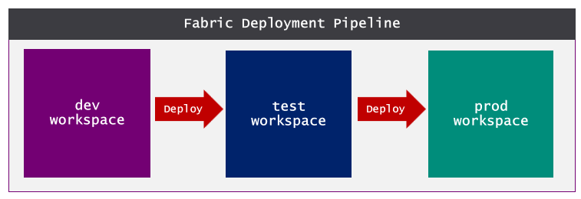
Deployment pipelines were designed to assist with continuous deployment and the release process. But that's only the second half of the whole CI/CD story. The use of deployment pipelines should be combined together with Fabric GIT integration to implement the full CI/CD lifecycle.
For example, you can design the development process using feature workspaces and feature branches where changes are merged back to a release branch. Updates merged into the release branch can then be used to synchronize workspace items in the dev workspace using an update from GIT operation. Once changes from the development process have propagated to the dev workspace, the deployment pipeline is then used to deploy changes to the test workspace and then on to the prod workspace.
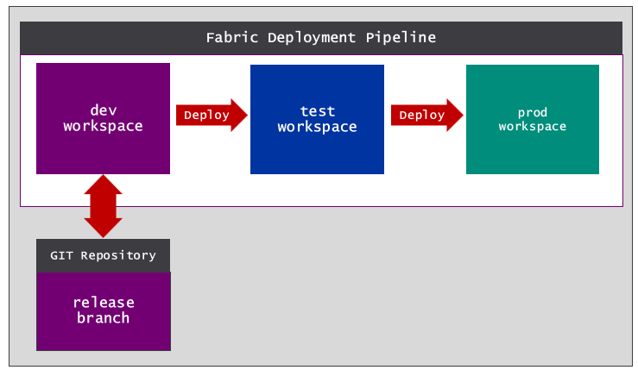
Deployment pipelines were designed to hide many of the low-level details of pushing changes to workspace items across workspaces. Using deployment pipelines is discussed further in Chapter 3 - Building a Release Process with Continuous Deployment.

Contiguous Deployment using an API-driven workflow
Deployment pipelines provide the easiest way to implement a release process in a Fabric CI/CD project. However, deployment pipelines have a few noteworthy limitations which restrict you from using them in certain scenarios. For example, a deployment pipeline requires all workspaces to exist within the context of a single Entra Id tenant. You cannot use deployment pipelines if you're require to create the test workspace and prod workspace in a different Entra Id tenant then the dev workspace.
Deployment pipelines only support a one-to-one mapping between workspaces. Deployment pipelines do not support building a release process with a one-to-many workspace mapping. Supporting a release process with a one-to-many workspace mapping is required in multitenant scenarios where you need to create a sperate workspace for each customer from a single release branch serving as a workspace template. There are other scenario in which such as the case where you're required to deploy items definitions from a single branch to different deployment targets.
By developing an API-driven workflow, you can build a Fabric release process which overcomes the limitations of deployment pipelines. For example, you can build a release process with a one-to-many workspace mapping scheme.
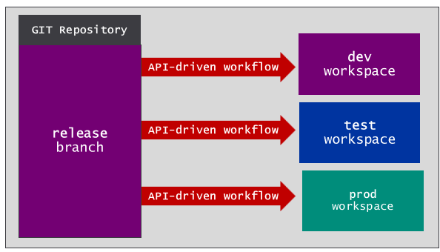
One option you have to implement an API-driven workflow is by writing code to explicitly calls public Fabric APIs. In this style of development, you can choose a programming language such as Python, C# or PowerShell to write logic which automate the creation and updating of items in a target workspace using item definitions retrieved from a source GIT branch. While this style of development might prove challenging for people not well-versed in calling REST APIs, it provides the greatest amount of control.
If you prefer a low-code approach, you can leverage a Python library named fabric_cicd. This library has become popular with Fabric data engineers and developers because it simplifies implementing an API-driven release process. It accomplishes this by fetching items definitions from a GIT branch and using them to create and/or update a matching set of items in a target workspace. You just need to configure a source GIT branch and a target workspace and fabric_cicd deals with most of the heavy lifting behind for you behind the scenes.

Parameterization using Variable Libraries
An essential aspect of the CI/CD lifecycle involves promoting changes through a sequence of stages. The canonical example is a release workflow which moves changes through environments such as dev, test and prod. When you need to test and validate code for a project across multiple environments, it’s essential to find an effective parameterization strategy.
The Fabric platform provides the variable library to assist with parameterization. The variable library is a creatable type of workspace item in which you can define a set of variables. Other workspace items such as notebooks, pipelines, copy jobs and dataflows can be defined to read variable values from a variable library. This makes it possible to avoid hardcoding configuration values that change across environments into your code.
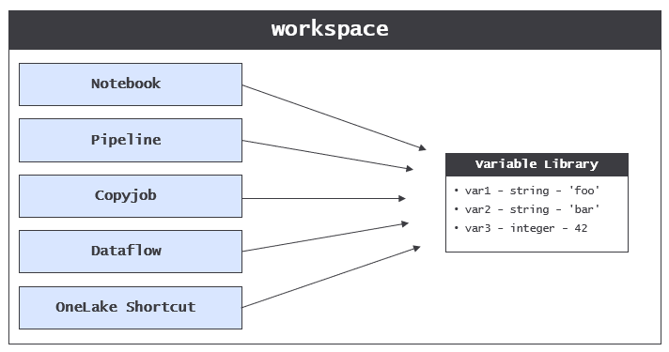
Consider the classic scenario in which you need to build a CD release process that moves changes through a sequence of environments such as dev, test and prod. The problem is that code in different environments must be configured to connect to different databases.
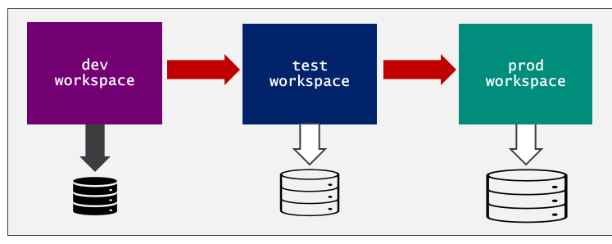
The variable library was created to solve the problem of parameterizing configuration settings across environments. A variable library allows you to avoid hardcoding the configuration settings required to connect to a database. Consider a scenario in which you must write Python code in a Fabric notebook to connect to a SQL database. The thing you want to avoid is hardcoding these configuration settings into your code as literal strings.
database_server = 'devcamp.database.windows.net'
database_name = 'ProductSalesDev'
The obvious problem is that these hardcoded values are specific to one environments. As an alternative, you can leverage a variable library along with its support for parameterization. You can start by creating a new variable library with a display name such as environment_settings. Next, you can add two string variables named database_server and database_name.
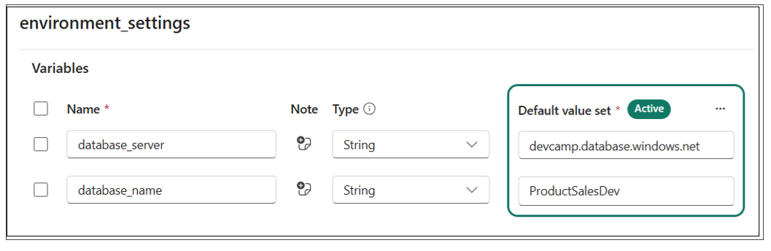
Once you have created the variable library with the two variables, you can remove the hardcoded configuration values from the notebook and replace them with code to read the variable values at run time as shown in the following code listing.
database_server = notebookutils.variableLibrary.get("$(/**/environment_settings/database_server)")
database_name = notebookutils.variableLibrary.get("$(/**/environment_settings/database_server)")
You have learned that a variable library allows you to add variables. That's probably not too surprising. However, variable libraries have another important dimension used to provide parameterization support across multiple workspaces. More specifically, Fabric allows you to extend a variable library using value sets.
A variable library is a collection of variables where each variable is defined with a name, a type and a default value.
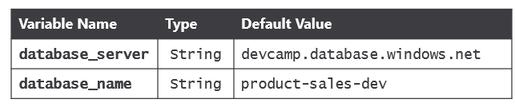
The purpose of a value set is to provide an alternate set of values for each of the variables in the variable library. Consider an example of a variable library in which the default values have been configured for the dev environment. You can extend the variable library by adding a value set for the test environment and a second value set for the prod environment.
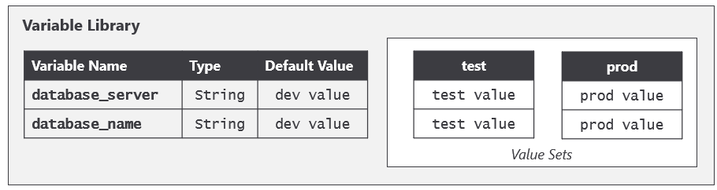
The item definition for a variable library includes variables and values sets. However the item definition does not contain anything to indicate which value set is active. That's because Fabric maintains a separate workspace-level setting that tracks which value set is the active value set for that workspace. That means three different workspaces could each contain a variable library with an identical item definition, yet each workspace can be configured to use a different value set.
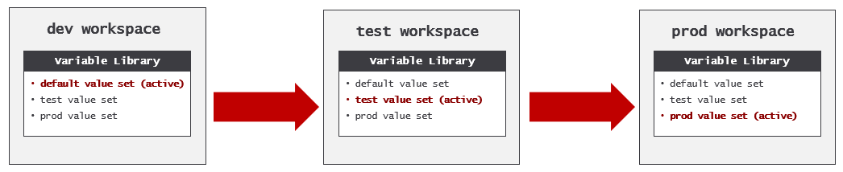

Understanding Workspace Items
Microsoft created the Fabric platform by integrating several existing products including Azure Data Factory, Azure Synapse and Power BI. Microsoft's motivation to integrate these products together has been to create a unified platform for a wide variety of projects related to data analysis and AI. In this integration process, Microsoft was presented with the challenge of making artifacts, components and features from different products work together. This led Microsoft to design the Fabric platform on top of a core abstraction. This is abstraction is that of the workspace item.
The Fabric platform is built upon a set of backend services known as workloads. For example, there is a Data Factory workload which provides workspace item types used in ETL processes such as DataPipeline and Dataflow. There is a Data Engineering workload which provides workspace item types familiar to Azure Synapse developers such as Lakehouse and Notebook. There is a Power BI workload which provides item types for analytics such as SemanticModel and Report.
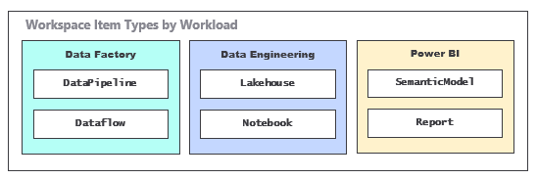
This is just a small sample of the workloads and workspace items types available in Fabric. Currently, Fabric supports over 30 creatable workspace item types and the list is constantly growing. Two years from now there will likely be new creatable workspace item types that nobody even knows about yet.
The core abstraction of the workspace item in Fabric is what allows artifacts from different workloads to behave in a similar manner. The Fabric platform defines the following set of requirements that each workspace item type must implement to fully support Fabric CI/CD tools.
- Workspace items must support serialization to item definitions for GIT integration
- Workspace items must support deserialization from item definition pulled from GIT branch
- Workspace items must support relations management during deserialization
- Workspace items must support deployment pipelines
- Workspace items must support parameterization using variable library
- Workspace items must support CRUD APIs with item definition for create/update
- Workspace items must support service principal when calling CRUD APIs
Not every workspace item type supports all of these requirements. This can be the case for workspace item types that are still in a preview release. There is also a number of workspace item types that have reached general availability (GA) such as warehouses, but do not yet meet these requirements. While Microsoft is working towards meeting these requirements in all workspace item types, items that do not meet these requirements require various workarounds.

Workspace Item Definitions
Item definitions represent an essential component type in the Fabric platform's support for CI/CD, As you've seen, an item definition can be represented as a set of item definition files. Every item definition requires a common file named .platform which is known as the platform file. The platform file contains metadata such as the item type and display name.
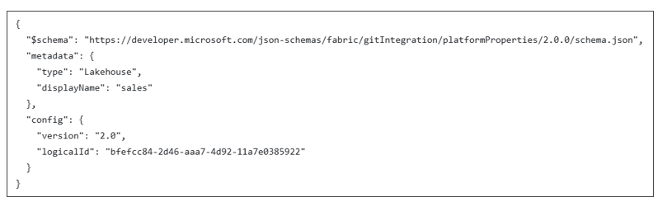
In addition to the platform file, each workspace item type defines its own unique set of requirements for the files required and/or allowed in an item definition. For example, the item definition for a notebook is simple. It just requires one additional item definition file named notebook-contents.py.
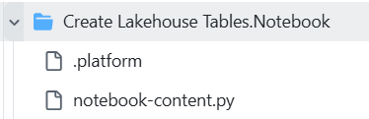
The item definition for a lakehouse requires a different set of files.
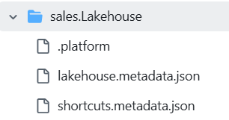
Other types of workspace items can have item definitions that are far more complex. For example, the item definition for a semantic model can include dozens or even hundreds of TMDL files.
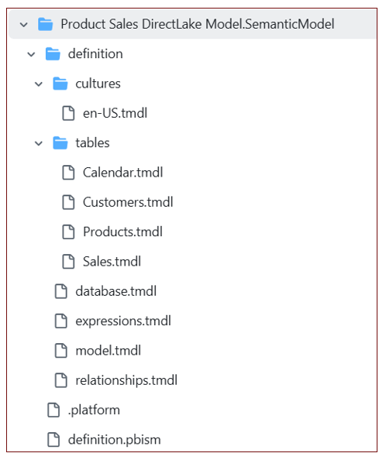
While an item definition with a large number of files is more complicated, it also allow for CI/CD and collaboration in a much more granular fashion. Consider the benefit of splitting out each table in the definition of a semantic model into its own file? It allows one developer to work on the measures in the Sales table while another developer is making changes to the Calendar table. This extra granularity is essential when a team of developers are all working on the same semantic model.
In general, you should gain a basic understanding of item definition files for the workspace items types you are working with in a Fabric CI/CD project. The easiest way to do this is to examine the files in the item definitions that have been written to a GIT branch using Fabric GIT integration support.
Additonal information About Fabric Item Definitions
- Item management overview
- Item definition overview

The Role of the LogicalId
Using Fabric GIT integration, you are able to replicate a set of workspace items across multiple workspaces. As an example, imagine you have created a lakehouse named sales and then you have replicated the lakehouse across three different workspaces. Each workspace contains its own distinct instance of the sales lakehouse. All three item instances share the same type and display name. Yet each item instance has its owns unique id.
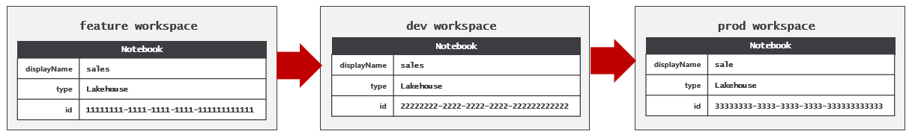
Fabric integration needs a way to track that these three item instances are all associated with a single logical item. This is the reason why Fabric GIT integration includes a logicalId property in the platform file for each workspace instance.
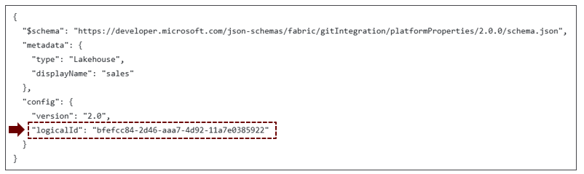
Fabric GIT integration uses logicalId to associate multiple item instances that all represent the same logical item. While each the item instance has a unique id, all item instance share the same logicalid. 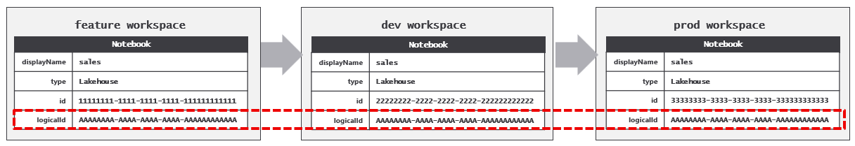
The logicalId is important because it allows workspace items to abstract away item instance ids that are specific to a single workspace. This level of indirection makes it possible for workspace items to automatically resolve their intra-workspace dependencies as part of the GIT synchronization process.
Take an example of a Fabric solution built using a lakehouse, notebook and a pipeline. Assume that the notebook has a dependency on the lakehouse and that the pipeline has a dependency on both the lakehouse and the notebook. After you have built out the solution in the dev workspace, there are three established dependencies between these workspace items.
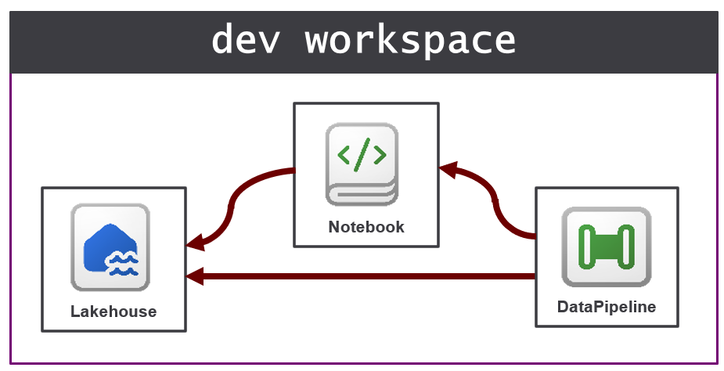
Now think about what happens when you use Fabric GIT integration to replicate these three workspaces items from the dev workspace to the prod workspace. The outcome you do not want is for workspace items created in the prod workspace to retain their dependencies pointing back to an item in the dev workspace. Instead, the desired outcome is for each workspace item to resolve its own dependencies to its related items in the same workspace.
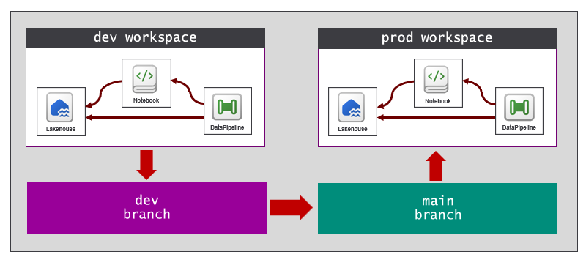
It is not likely that you will ever need to work directly with the logicalId. It is an internal property which is updated and read by Fabric behind the scenes. Fabric automatically generates the logicalId for a workspace item the first time it is serialized to an item definition and written to a GIT branch. As you have seen, workspace items can manage and reestablish relations as they are replicated across workspaces. A key point is that workspace items are designed with behavior to reestablish relations to other workspace items. The implementation of this behavior in workspace items relies on the logicalId to reestablish intra-workspace dependencies.
You should never modify a logicalId value as this is an unsupported action that can lead to unpredictable behavior.
Some workspace items auto-bind and other do not. One important CI/CD task to automate is binging items that do not automatically bind.

Getting Started with Automation in Fabric
Why do we care?
- Infrastructure setup
- Workspace item deployment
- Post-deploy tasks and post-sync tasks
Automation becomes an important aspect setting up and managing a Fabric CI/CD project. At the start of a project, there is a need to provision tenant-level items such as workspaces, capacities, connections and deployment pipelines. There will be an ongoing need to create new feature branches, feature workspaces and GIT connections. In some scenarios, there could be a need to automate synchronizing changes back and forth between GIT branches and workspaces. There will is also be a need to update items and their underlying item definitions when writing the code for post-deploy tasks and post-sync tasks.
ClickOps? No thanks. Automation is the way to go
While many of the tasks for setting up a Fabric CI/CD project can be completed by hand, they can also be automated by writing scripts or programming logic which call public Microsoft APIs. Whenever possible, it's best to build CI/CD processes that don't require manual intervention because that can lead to unnecessary delays and problems caused by human error. The ability to automate an end-to-end setup process using code which can be tested and versioned leads to greater levels of reliability and scale.
There are several public APIs from Microsoft that are used to automate Fabric CI/CD tasks. The Fabric REST APIs provides the ability to create workspaces, connections and workspace items. However, you must use the Azure Microsoft Fabric REST API to create and manage Fabric capacities. The Power BI REST API provides the ability to automate tasks on Power BI items such as refreshing semantic models and binding them to connections. The Tabular Object Model is another powerful API that provides extensive coverage for reading and modifying semantic models.
You can also take advantage of the Azure Data Lake Storage (ADLS) Gen2 APIs and their ability to access content in OneLake. This makes it possible to read and write files in the Files section of a lakehouse. You also might need to automate tasks within a GIT repository such as creating a new feature branch or creating and completing a pull request. To automate tasks with Azure DevOps repositories, you can use the Azure DevOps Services REST APIs. To automate tasks with GitHub repositories, you can use the GitHub REST APIs.
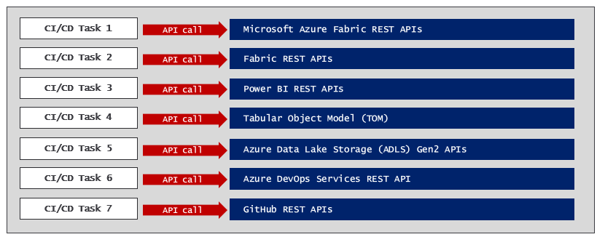
As you can see, there are quite a few APIs that make up the complete landscape for automating tasks in Fabric.
Every call to a Microsoft API executes under the identity of a specific security principal. Microsoft APIs support two types of principal identity which are user principals and service principals. In general, it is a much better choice to execute API calls for CI/CD tasks as a service principal. This is especially true when code executes in a cloud-based environment such as with Azure pipelines or GitHub Actions workflows.
Links to documentation for Microsoft APIs used in Fabric development
- Azure Microsoft Fabric REST APIs
- The Fabric REST APIs
- Power BI REST APIs
- Tabular Object Model
- ADLS Gen2 APIs
- Azure DevOps Services REST API
- GitHub REST API
There are several approaches to automating Fabric CI/CD tasks using public Microsoft APIs. Over the next few sections you will see several different options which make things easier including the Fabric CLI, Semantic Link Labs and Terraform. There is always the option of writing code that calls these Microsoft APIs directly using the programming language of your choice.

Automating Tasks using the Fabric CLI
The easiest approach for automating tasks in Fabric is to leverage the Fabric CLI which hides many of the low-level details for authenticating with Entra Id and executing HTTP requests against Microsoft API endpoints. Fabric CLI also makes it easy to follow the best practice of authenticating as a service principal when developing CI/CD workflows.
Fabric CLI is a is a command-line interface tool that supports both an interactive mode and a scripting mode. The interactive mode allows a developer or workspace administrator to type in and execute a sequence of commands. For example, a developer can use Fabric CLI in interactive mode to quickly create a new workspace and then to create a lakehouse inside that workspace. Fabric CLI also provides commands to load data into lakehouse tables and to automate running notebooks and pipelines which contain ETL logic.
Fabric CLI support for scripting mode can be used to develop CI/CD workflows that run as an Azure pipeline or a GitHub Actions workflow. You can develop Fabric CLI scripts in PowerShell or in Python to create workspaces, capacities, connections and workspace items. Fabric CLI provides an export command to export an item in a workspace to an item definition which consists of a set of item definition files in a local folder. Likewise, Fabric CLI provides a complimentary import command used to create or update an item in a target workspace using an item definition in a local folder.
The Fabric CLI doesn't provide built-in commands to cover every possible call to the Fabric REST APIs. However, Fabric CLI provides a backdoor with the api command. The api command allows an advanced user to specify the target URL and any JSON to be passed on the request body. This opens up the possibility of using the Fabric CLI to call any APIs made available through the Fabric REST APIs and the Power BI REST APIs.
Behind the scenes, Fabric CLI calls to several Microsoft APIs to complete its work. This includes the Fabric REST APIs, the Power BI REST API, ADLS Gen2 APIs and the Azure Microsoft Fabric REST APIs. Keep in mind that all of these APIs have different endpoints and different requirements for acquiring access tokens. However, that is something you don't have to worry about when using Fabric CLI. Fabric CLI provides a single set of commands which abstract away the underlying APIs to provide a single, focused experience for Fabric automation.
Links for more information about Fabric CLI
- Fabric CLI
- CLI Modes
- Fabric CLI Commands
- Fabric CLI Usage Examples

Automating CI/CD Tasks using Semantic Link Labs and Python
Semantic Link is a feature in Microsoft Fabric that bridges the gap between data science and data analytics by connecting Power BI semantic models with Python and Spark environments. Semantic Link allows data scientists to load the data from a semantic model into a FabricDataFrame object which can be used directly with many popular data science libraries such as pandas and scikit-learn.
Semantic Link Labs is a Python library designed to provide access to Semantic Link for developers working in Fabric. However, Semantic Link Labs goes far beyond just wrapping Semantic Link. It adds a significant amount of functionality for working with workspace item such as semantic models, reports, lakehouses, notebooks and variable libraries. Beyond the scenes, Semantic Link Labs completes its work by calling to other APIs including Fabric REST APIs, Power BI REST APIs and the Tabular Object Model. Developers using Semantic Link Labs benefits from the simplicity of a single API surface without having to think about the details of acquiring access tokens and dispatching calls to multiple APIs.
Semantic Link Labs wraps the Tabular Object Model (TOM) to provide in-depth support for reading and updating semantic model definitions. For example, Semantic Link Labs makes it simple to redirect the datasource for a semantic model from one lakehouse to another. Semantic Link Labs can be used to run refresh operations on semantic models and to update incremental refresh policy. Furthermore, Semantic Link Labs includes support for migrating semantic models created using DirectQuery mode or Import mode over to use DirectLake mode instead.
Semantic Link Labs support updating and analyzing Power BI reports that use the new PBIR format for their item definitions. This makes it possible to analyze report metadata and to find broken visuals. This can help to build your understanding of the high-level structure of a report definition and to troubleshoot errors.
Semantic Link Labs provides the ability to work with workspace items from the Data Engineering workload such as lakehouses, notebooks and environments. Semantic Link Labs simplifies creating lakehouses and notebooks and configuring a notebook to use a specific lakehouse as its default lakehouse. There is also support for running jobs for notebooks and pipelines and monitoring job execution to determine whether the job completed successfully.
Semantic Link Labs can provide assistance setting up Fabric CI/CD projects that use deployment pipelines. There are functions you can call to automate the provisioning of a deployment pipeline with a specific number of stages and the assignment of workspaces to deployment pipeline stages. Semantic Link Labs additionally provides the ability to automate the deployment of workspace item changes from one stage to the next.
Semantic Link Labs can be used in CI processes to improve code quality. For example, you can create an automated process which uses Best Practice Analyzer to inspect the item definition for a semantic model or report. When a developer makes updates to a semantic model or report and then tries to commit those changes, that can trigger a workflow. The workflow can inspect the updated item to determine whether it follow all the best practice rules. If the workflow detects that the updates to the item violate best practices, it can place responsibility on the developer to fix the problem before any changes can be committed to a feature branch.
An important aspect of using the Semantic Link Labs library is that is only works inside the Fabric environment. You cannot load Semantic Link Labs in a non-Fabric environment such as Azure pipelines or GitHub Actions workflows. In order to leverage Semantic Links Labs from a non-Azure environment, you must maintain code which uses Semantic Link Labs in a Fabric notebook and then call the Fabric REST APIs to automate running the notebook.
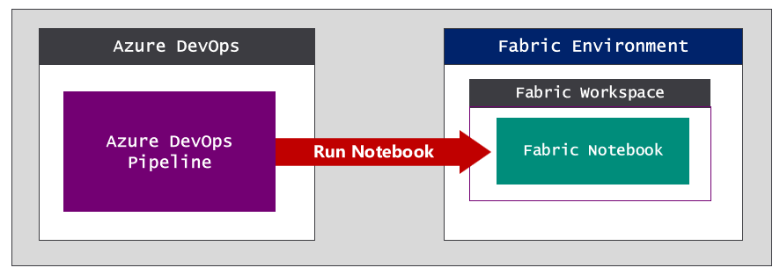\
Links for Semantic Link Labs
- What is semantic link?
- Semantic Link Labs
- Semantic Link Labs Code Examples

Automating Infrastructure CI/CD Tasks with Terraform
Terraform is an open-source tool built on the CI/CD principle of infrastructure as code (IaC). Terraform lets you define and set up the infrastructure for a Fabric CI/CD project using configuration files rather than ad hoc code or manual processes. Terraform makes it possible to define the infrastructure setup as code for resources such as servers, networks and databases. Once the infrastructure setup has been defined in code, it can be version-controlled, automated, and managed consistently across different environments.
Terraform has become an industry standard for provisioning Azure resources such as storage accounts, Azure SQL database and Azure Key Vault. Given that a Fabric capacity is an Azure resource, Terraform provides a good fit for provisioning capacities at the start of a Fabric CI/CD project.
Microsoft has created a Fabric Provider for Terraform that makes it possible to script out provisioning instructions to create tenant-level items in Fabric such as workspaces, connections, gateways and deployment pipelines. The ability to define and version code to provision tenant-level items provides a valuable compliment to Fabric GIT integration which only provides support at the level of the workspace item.
Resources for Terraform
- Terraform Documentation
- Terraform on Azure documentation
- Microsoft Fabric Provider

Getting Started with the Fabric REST APIs
Fabric CLI and Fabric Link Labs were both created to simplify automation in Fabric . Both have become very popular because they provide a productivity-oriented façade on top of multiple Microsoft APIs. However, some developers and development teams prefer full control over simplicity. This is especially true for experienced developers who are familiar with Entra Id authentication and executing HTTP requests against REST API endpoints. Calling directly to public APIs such as the Fabric REST API provides the great amount of flexibility and control.
The Fabric REST APIs were designed with open standards which make it accessible from a wide variety of development platforms and programming languages. The architecture of the Fabric REST APIs is built upon three fundamental concepts which are paginated results. long-running operations and throttling. Developers who begin working with the Fabric REST APIs must understand these three essential concepts in order to write code that is correct, efficient and reliable.
Fabric REST APIs that return list-based results implement a pattern known as paginated results. The motivation for paginated results is the need to avoid passing too much data across the network at once. For example, an API call might request a list that is too large to pass back to the caller in a single response body. The paginated results pattern allows an API endpoint to pass data to the caller in smaller chunks (i.e. pages). The use of paginated results improves the performance and efficiency of API calls, especially when dealing with a large amount of data.
Fabric REST APIs that run asynchronously implement a pattern known as long-running operations. An API call that runs as a long-running operation returns a status code of 202 Accepted to indicates that a job (i.e operation ) to be completed is queued up and will run sometime in the future. The caller who receives a 202 Accepted response is responsible to take additional steps to monitor the operation’s progress and to retrieve the final result when a long-running operation completes.
Fabric REST APIs enforce throttling to maintain optimal performance and reliability. Fabric throttling behavior limits the number of API calls which can be executed by a caller within a 60-second time window. Once a caller has reached the throttling limit in a specific time window, future calls in the same window will be rejected with a status code of 429 Too many requests. Fabric REST API calls which return a 429 error will include the Retry-After response header. The value of the Retry-After header tells the caller how many seconds to wait before a new time window begins when the call can be resubmitted.
Microsoft offers Software Development Kits (SDKs) for the Fabric REST APIs to .NET developer and to Python developers. These SDKs provides a significant productivity boost to developers by hiding many of the tedious and low-level details of HTTP executing HTTP requests such as passing access tokens and converting back and forth from JSON to strongly-typed .NET objects. These SDK also provide support to seamlessly deal with paginated results, long running operations and throttling error behind the scenes.
Fabric REST API Fundamentals
- Pagination
- Long running operations
- Throttling
- .NET SDK
- Python SDK (no link yet - hoping these will be a link by January 2026)

Programming with Item Definitions
Programming directly against the Fabric REST APIs is powerful because it provides full control when creating and updating workspace items. This style of programming might be tricky at first because you must learn how to update item definition files and how to pass an item definition across the network. Once you get over these hurdles, you will find that this style of programming yeilds the greatest level of control.
There are three primary scenarios in which you program directly with item definitions. First, you can pass an item definition when calling the Create Item API. Second, you can update an existing item by passing an item definition in a call to the Update Item Definition API. Third, you retrieve the item definition for an existing item by calling the Get Item Definition API.
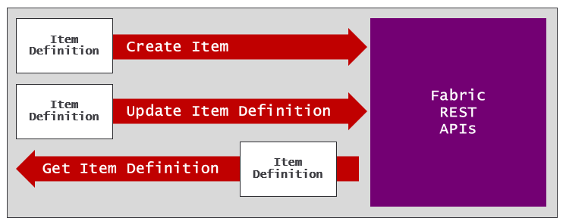
Let's walk through a scenario in which creating a workspace item requires updating an item definition file. In this scenario, imagine you have just used the Fabric REST API to create a workspace and a lakehouse inside tht workspace. Now it's time to create the notebook. However, you have to create a notebook in such a way that it's configured to use the lakehouse as its default lakehouse.
A notebook item definition requires one file named notebook-content.py in additon to the platform file.
The notebook-content.py file has metadata at the top which tracks the configuration of its default lakehouse. This metadata is hidden from the user when a notebook is opened in Fabric notebook editor. However, you can view this metadata by examining the notebook-content.py file as shown in the following screenshot.
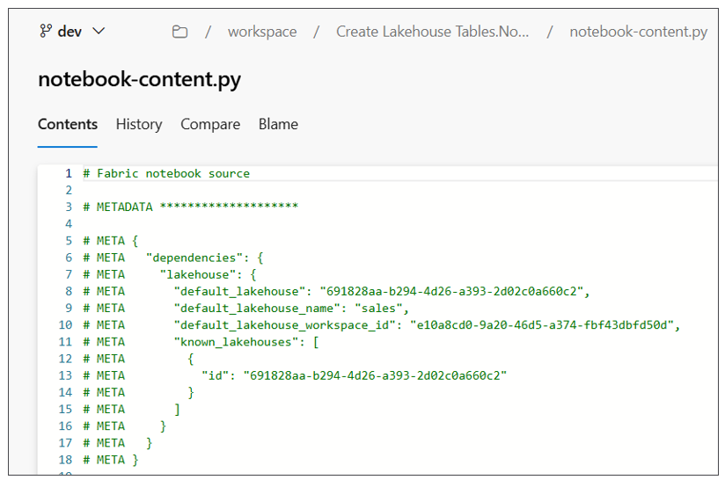
The problem is that you need to update notebook-content.py with the correct workspace id and lakehouse id. First, you need to track the ids that are generated by Fabric when you create the workspace and the lakehouse. After that, you need to perform some type of search-and-replace operation to substitute the workspace id, lakehouse id and lakehouse name into the content of notebook-content.py.
# Synapse Analytics notebook source

# METADATA ********************

# META {
# META "synapse": {
# META "lakehouse": {
# META "default_lakehouse": "{LAKEHOUSE_ID}",
# META "default_lakehouse_name": "{LAKEHOUSE_NAME}",
# META "default_lakehouse_workspace_id": "{WORKSPACE_ID}",
# META "known_lakehouses": [{ "id": "{LAKEHOUSE_ID}" }]
# META }
# META }
# META }
Once you have updated the contents of notebook-content.py, the next thing you need to do is to pass item definition files across the network when calling to the Create Item API. The next problem you encounter is how to pass multiple files across the network in an HTTP request body. The answer to this problem is to format the content of each file using base64 encoding.
When you format the contents of a item definition file with base64 encoding, you can add that encoded content in a JSON element as a string value. This makes it possible to transmit all the files for an item definition in a call the Create Item API.
{
"displayName": "Create Lakehouse Tables",
"type": "Notebook",
"definition": {
"parts": [
{
"path": ".platform",
"payload": "********************BASE64-ENCODED-FILE-CONTENT"********************"
"payloadType": "InlineBase64"
},
{
"path": "notebook-content.py",
"payload": "********************BASE64-ENCODED-FILE-CONTENT"********************"
"payloadType": "InlineBase64"
}
]
}
}
Now consider another scenario in which you want to update an existing workspace item. Perhaps you'd like to redirect the default lakehouse for existing notebook from one lakehouse to another. You can accomplish this using the following steps.
- Call Get Item Definition to retrieve current item definition
- Extract the notebook-content.py file content and convert it from base64 to plain text
- Perform substitution on the notebook-content.py file contents to update the workspace id and lakehouse id
- Convert the updated file contents for notebook-content.py back into the base64 encoded format
- Call Update Item Definition passing updated item definition.
Directly manipulating item definition files is a powerful technique that assumes you know what you are doing. If your update to an item definition file results in invalid syntax, you will experience errors calling Create Item or Update Item Definition.
Resources for working with item definitions
- Fabric item definitions overview
- Create Item API
- Get Item Definition API
- Update Item Definition API

Developing Fabric CI/CD Workflows
Now that you've seen your options for how to write the code to implement Fabric CI/CD tasks, the next question is where to deploy that code. The answer to this question is simple. You want to deploy and run your code in the same GIT repository that holds the item definitions. The next two sections will introduce the topic of hosting custom code in Azure DevOps and GitHub.

Developing Azure Pipelines
Azure DevOps is a Microsoft cloud platform that provides a suite of development tools for software teams to plan, build, test, and deploy applications. It's designed with CI/CD features to support the entire software development lifecycle. When you create a new project in Azure DevOps, the project is automatically created with a GIT repository of the same name. For example, creating a project named Project1 will automatically create a repository named Project1. In many scenarios, the GIT repository that's created along with the project is all you need. However, you can always add other repositories to a project if it's needed.
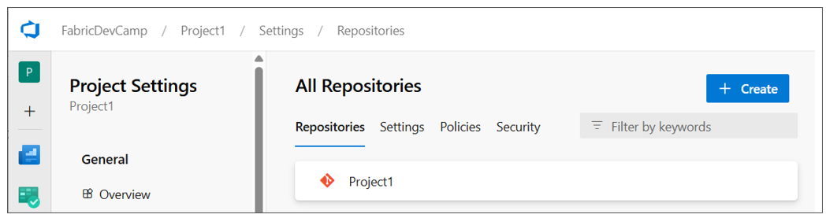
Azure Pipelines is the CI/CD workflow service that's built into Azure DevOps which provides features to integrate, test and deploy code using the principals of CI/CD. An Azure pipeline can be configured to run on-demand or on a schedule such as every night at midnight. Alternately, you can define an Azure pipeline with a trigger to run automatically in response to a code commit or the completion of a pull request.
To create an Azure pipeline, you must first add a YAML file into your repository. Once you have added the YAML file, you must then explicitly register it with the Azure DevOps project. This can be accomplished through the Azure DevOps user interface or it can be automated using the Azure DevOps CLI or the Azure REST APIs. Once a pipeline has been registered, you should be able to see it in the Pipelines page in an Azure DevOps project.
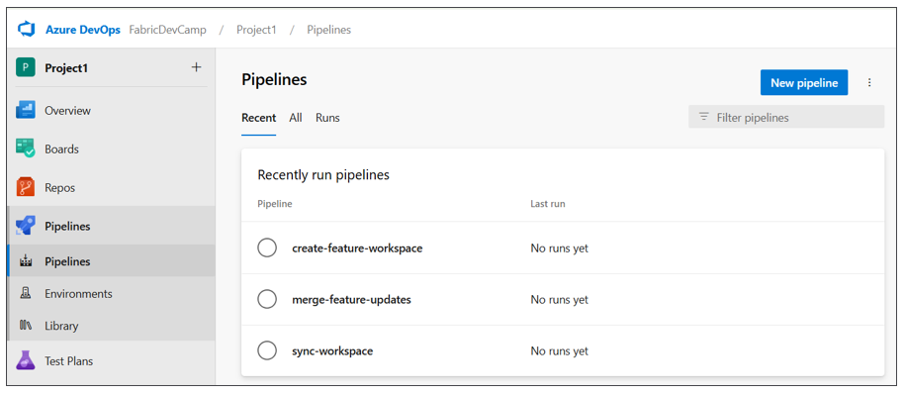
You can write the code for an Azure pipeline in a programming language such as PowerShell or Python. This is accomplished by referencing the script with the PowerShell or Python code from the YAML file. The following screenshot shows an example of three YAML files for three Azure pipelines in the .pipelines folder and their associated Python scripts in the src folder. Below these two folders you can also see the workspace folder which contains the item definitions for a specific workspace.
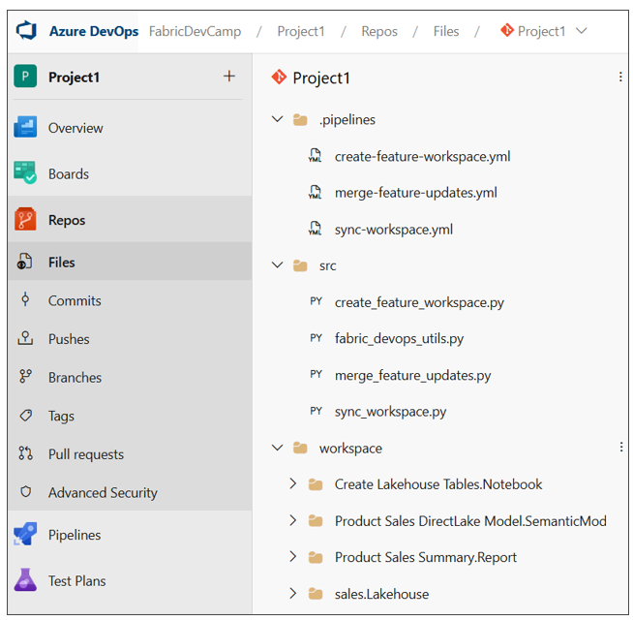
As you begin to develop Azure pipelines for a Fabric CI/CD project, you will find there's a need to track environment settings such as the ids for workspaces, capacities, users and groups. You might also need authentication credentials for an Entra Id application so your code can authenticate as a service principal. The Azure pipelines service allows you to create variables to track these types of environment settings.
In order to create variables for use in Azure pipelines, you must first create a variable group. Once you have created a variable group, you can then add a set of named variables along with their values. The following screenshot shows the typical set of variables created for Azure pipelines in a Fabric CI/CD project.
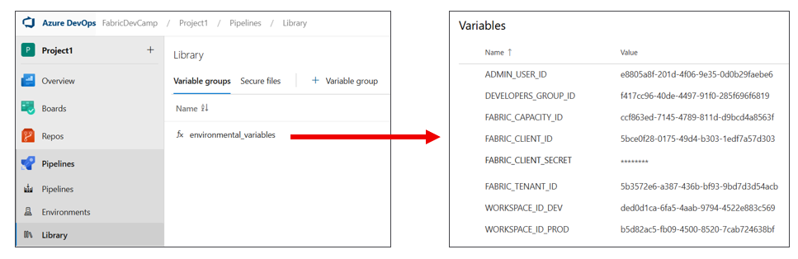
When you create a variable that contains sensitive data, you can mark that variable as a secret. For example, your pipeline might need to access to a client secret used to authenticate as a service principal. When you mark a variable as a secret, the Azure DevOps service does several important things to protect its value. First, the variable is persisted in the cloud using an encrypted format rather than plain text. Second, the value cannot be viewed in the Azure DevOps user interface after saving. Third, the secret value is masked in logs. If the secret value appears in pipeline output, Azure Pipelines replaces it with *** so it won't be visible in build logs.
Variable groups in Azure DevOps can also be integrated Azure Key Vault. That means you can configure access to secrets in Azure Key Vault from code running in an Azure pipeline. This makes it possible to benefit from Azure Key Vault features such as conditional access policies, auditing, and secret rotation.
By default, an Azure pipeline does not have access to the variables in a variable group. Instead, you must configure permissions for a variable group to ensure the code in your Azure pipelines has access to its variables and secrets. These permissions can be configured using the Pipeline permissions dialog in the Azure Devops user interface or by using the Azure DevOps CLI or the Azure REST APIs.
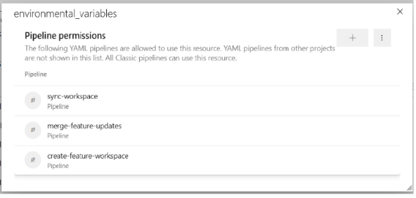
As you begin to develop with Azure pipelines, you should become familiar with monitoring pipeline runs in order to test and debug your code. It's important to add logging to your code to report on successful operations and to provide diagnostic information about any errors that occur. The following screenshot shows how an Azure pipeline can be written to log its progress in a Fabric CI/CD workflow.
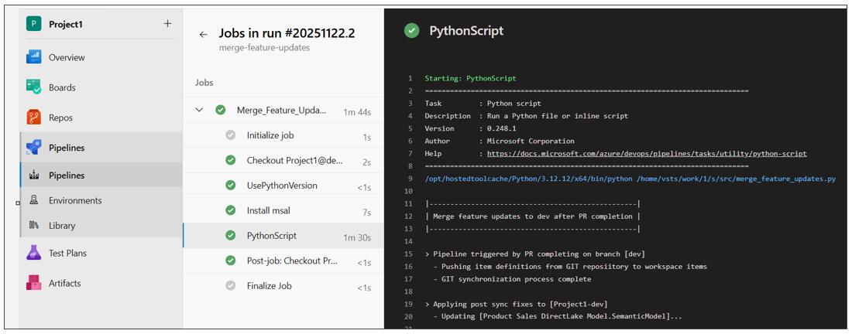
Azure DevOps Pipeline Resources
- Azure Pipelines documentation
- Key concepts
- YAML pipeline editor
- Manage variable groups
- Use Azure Key Vault secrets in Azure Pipelines

Developing GitHub Workflow Actions
GitHub is different from Azure DevOps with respect to how you work with projects and repositories. GitHub allows you to create repositories without first creating a project. While GitHub supports creating projects to assist with organizing repositories, the use of projects in GitHub is optional. When using GitHub as the GIT provider for a Fabric CI/CD project, you just need to create a repository to get started.
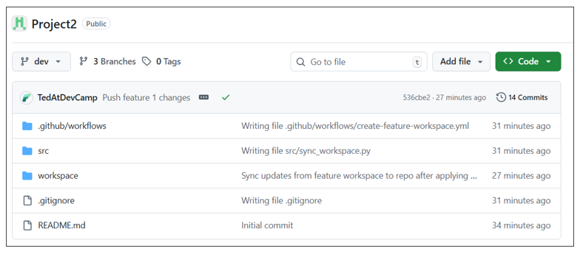
GitHub Actions is the workflow platform in GitHub that allows you to automate CI/CD tasks. You can create GitHub Actions workflows that can be run on-demand or run on a schedule. You can also configure workflows to run in response to events such as a code commit or the completion of a pull request.
With GitHub Actions, you create a new workflow by copying a YAML file into a special repository folder named .github/workflows. Unlike Azure pipelines, there is no need to register the YAML file with GitHub. Just coping to YAML file into the .github/workflows folder is all you need to do. Inside the YAML file, you can reference a script written in a language such as PowerShell or Python. The following screenshot shows a typical example of the file structure of a Fabric CI/CD project in a GitHub repository.
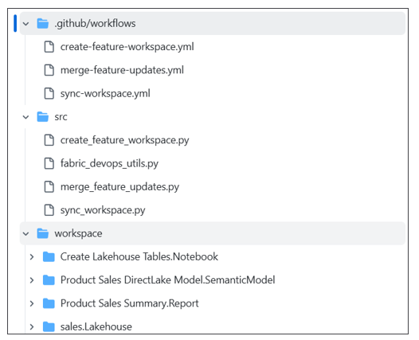
As you begin to develop Git Actions workflows for a Fabric CI/CD project, you need a way to track environment settings such as the ids for workspaces, capacities, users and groups. Your code might also need authentication credentials to authenticate as a service principal. GitHub allows you to create secrets and variables to track these types of environment settings.
You can create secrets in a GitHub repository by navigating to Settings and selecting the Secrets and variables > Actions. When you create a secret, GitHub will encrypt its value and redact it from logs. A GitHub Actions workflow decrypts a secret at runtime, injects it into your workflow and then immediately discards it from memory when the workflow completes.
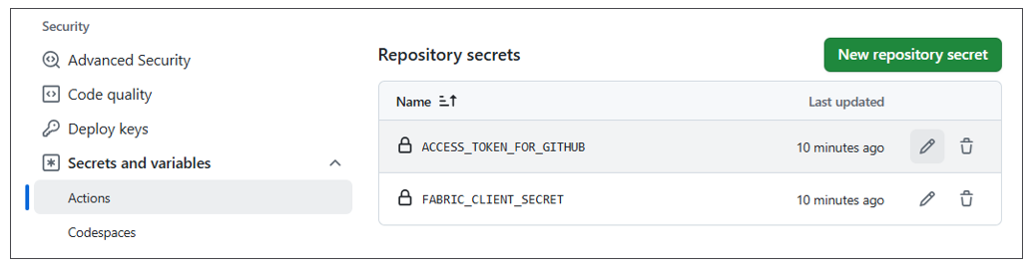
You can also add variables to a GitHub repository for environment settings that are not sensitive. The following screenshot shows an example of variables created for Azure pipelines in a Fabric CI/CD project.
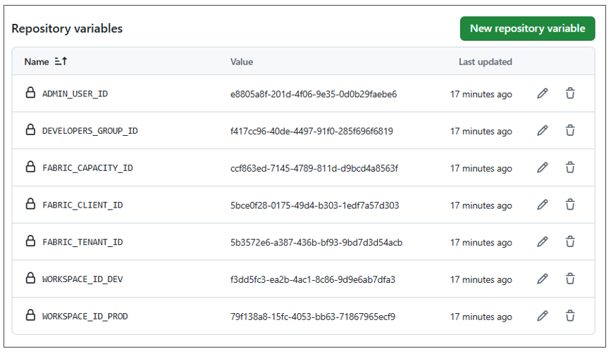
Unlike Azure pipelines, there is no need to configure permissions because GitHub Actions workflows automatically have access to secrets and variables in the same repository by default.
While creating secrets and variables at the repository level is adequate for some projects, you might find you need more granularity. GitHub supports a feature which allows you to create environments in a GitHub repository and then to create secrets and variables at environment scope.
Consider a CD release process in which workspaces don't exists within the same Entra Id tenant. For example, imagine the dev workspace, the test workspace and the prod workspace all exist in different Entra Id tenants. In this scenario, you will need different authentication credentials for each Entra Id tenant. You can start by creating three different environments in your GitHub repository named dev, test and prod.
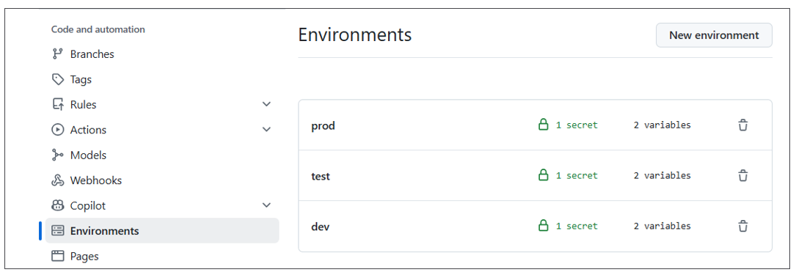
After that, you can configure each environment with the authentication credentials specific to its Entra Id tenant.
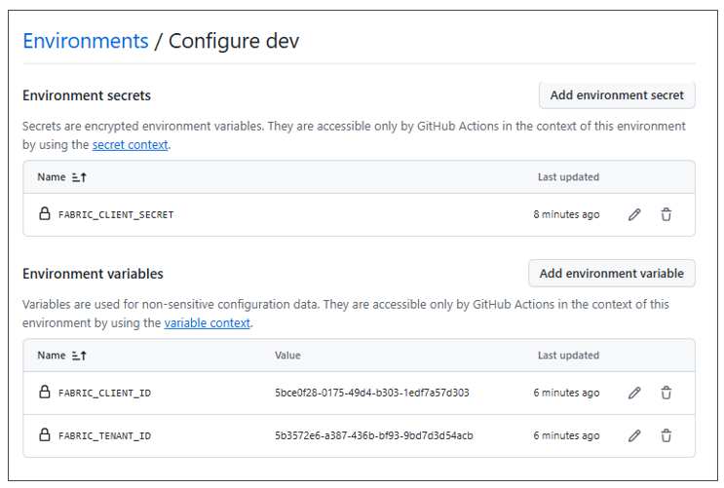
Once you have added the YAML file for a GitHub Actions workflow into the .github/workflows folder, you can view that workflow in the left navigation of the Actions page. You can also select a workflow see its run history.
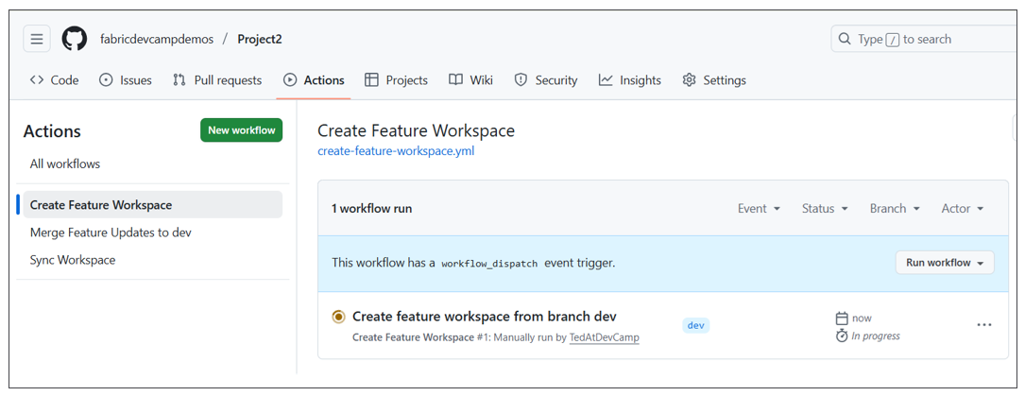
After selecting a workflow in the left navigation, you can drill into a specific workflow run and view its logs. You can also run a workflow on demand by dropping down the Run workflow menu and clicking the Run workflow button. If you need to collect information from the user before running the workflow, you can define input fields in the workflow's YAML file. The following screenshot shows an example of a workflow with input parameters that prompt the user with a textbox and two checkboxes.
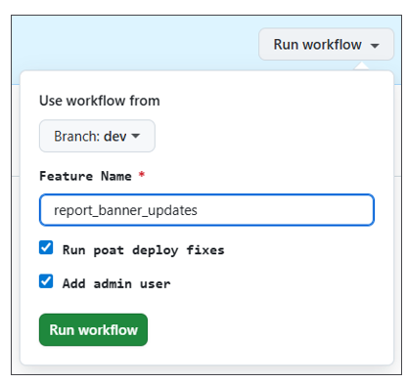
As you begin to develop GitHub Actions workflows, you should become familiar with monitoring workflow runs in order to test and debug your code. It's important to add logging to your code to report on successful operations and to display diagnostic information about any errors that occur. The following screenshot shows an example of an Azure pipeline written to log its progress in a Fabric CI/CD workflow.
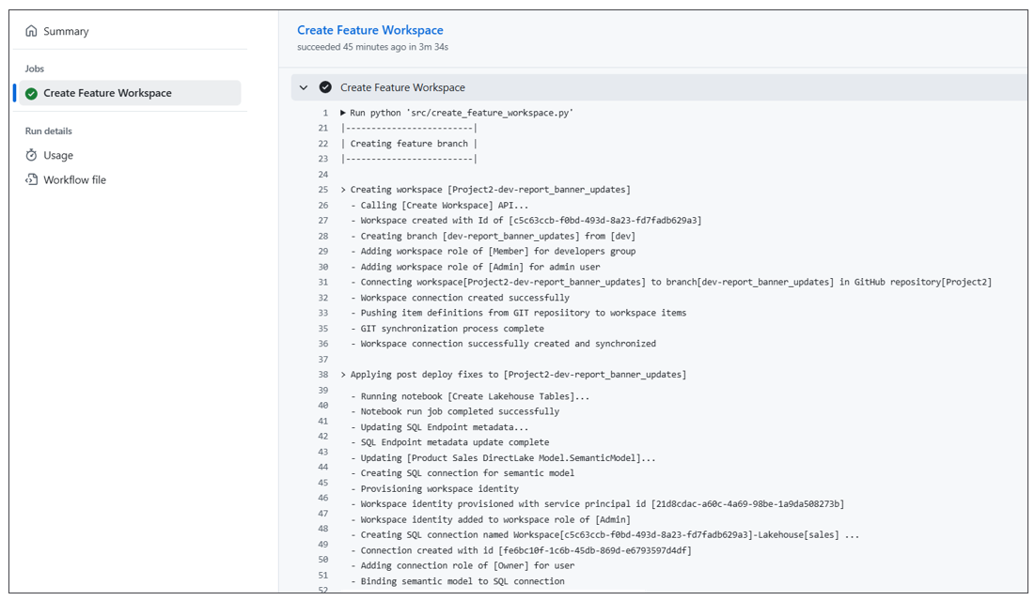
Resources for GitHub Actions Workflows
- Understanding GitHub Actions
- Workflows
- Variables
- Deployment environments

Summary
You have now completed an overview of the Fabric platform's support for CI/CD. You learned that Fabric GIT integration and the ability to connect a workspace to a GIT branch provide the foundation for continuous integration and continuous deployment. Fabric GIT integration is based on serializing workspace items into item definitions which can be written to a GIT branch as a set of item definitions. Fabric is also able to initialize an empty workspace using a set of item definitions in GIT.
You learned that deployment pipelines provide the easiest way to build a release process in Fabric for continuous deployment. You also know that GIT integration and deployment pipelines can be used together to build an end-to-end CI/CD workflow.
This overview introduced variable libraries which play an essential role in Fabric CI/CD. Variables libraries allow you to design a parameterization strategy by creating a set of variables and value sets. When used correctly, variable libraries help you to avoid writing code with hardcoded environment settings that change across environments and workspaces.
You learned there are several different approaches you can take for automating tasks in a Fabric CI/CD project. You can leverage tools and libraries like Fabric CLI, Semantic Link Labs and Terraform. You also have the ability to call Microsoft APIs directly if you feel the extra degree of control is worth the effort.
This overview introduced the workflow development environments for Azure DevOps and GitHub. The development experience in Azure DevOps is based on Azure pipelines while development experience in the GitHub is based GitHub Action workflows. Both development environments provide a similar ability to create workflows using YAML-based files and to provide your code with access to variables and secrets. You should become comfortable with writing, testing and debugging code in one of these development environments if you are the one responsible for automation in a Fabric CI/CD project.

